This is a list of the Fibonacci Sequence

0, 1, 1, 2, 3, 5, 8, 13, 21, 34, 55, 89, 144, 233, 377, 610, 987, 1597, 2584, 4181, 6765, 10946, 17711, 28657, 46368, 75025, 121393, 196418, 317811

The Fibonacci Sequence can be expressed in a spiral. (below)

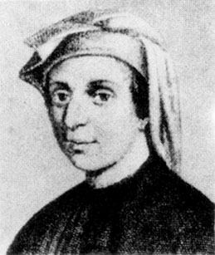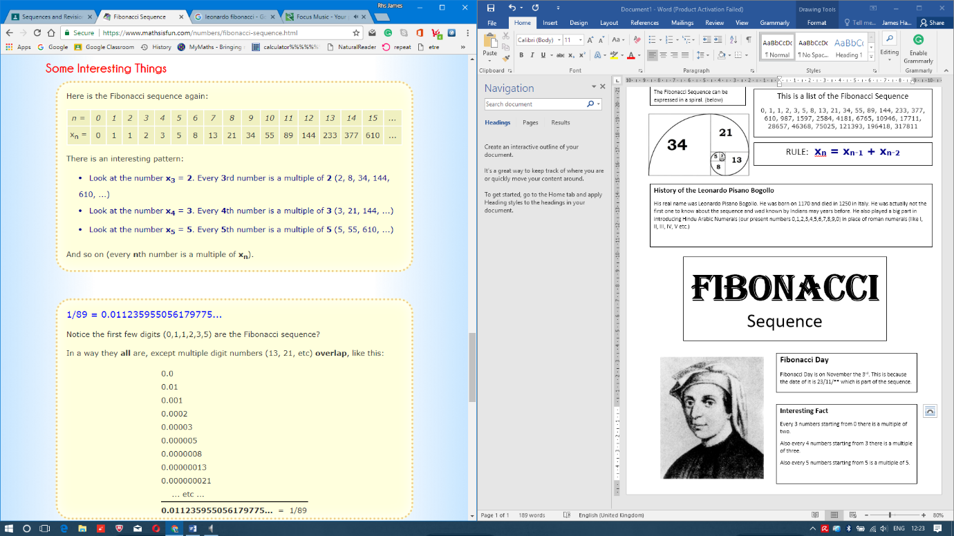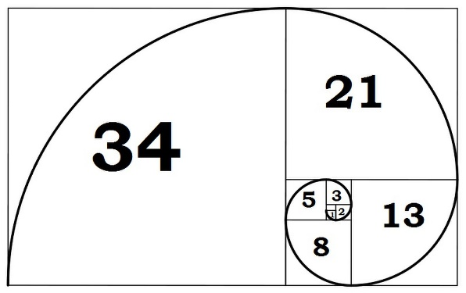

**Interesting Fact**

Every 3 numbers starting from 0 there is a multiple of two.

Also every 4 numbers starting from 3 there is a multiple of three.

Also every 5 numbers starting from 5 is a multiple of 5.

**Fibonacci Day**

Fibonacci Day is on November the 3rd. This is because the date of it is 23/11/** which is part of the sequence.

**Fibonacci**

Sequence

**History of the Leonardo Pisano Bogollo**

His real name was Leonardo Pisano Bogollo. He was born on 1170 and died in 1250 in Italy. He was actually not the first one to know about the sequence and wad known by Indians may years before. He also played a big part in introducing Hindu Arabic Numerals (our present numbers 0,1,2,3,4,5,6,7,8,9,0) in place of roman numerals (like I, II, III, IV, V etc.)

RULE:  **xn = xn-1 + xn-2**